Vocabulary Flipchart

To make this book, take an 8 ½” by 11” piece of paper and fold vertically

Fold the paper horizontally again and again, until you have 12 sections.

Open the paper and cut only one side from the edge to the vertical fold along each of the horizontal folds. Do not cut past the middle fold.

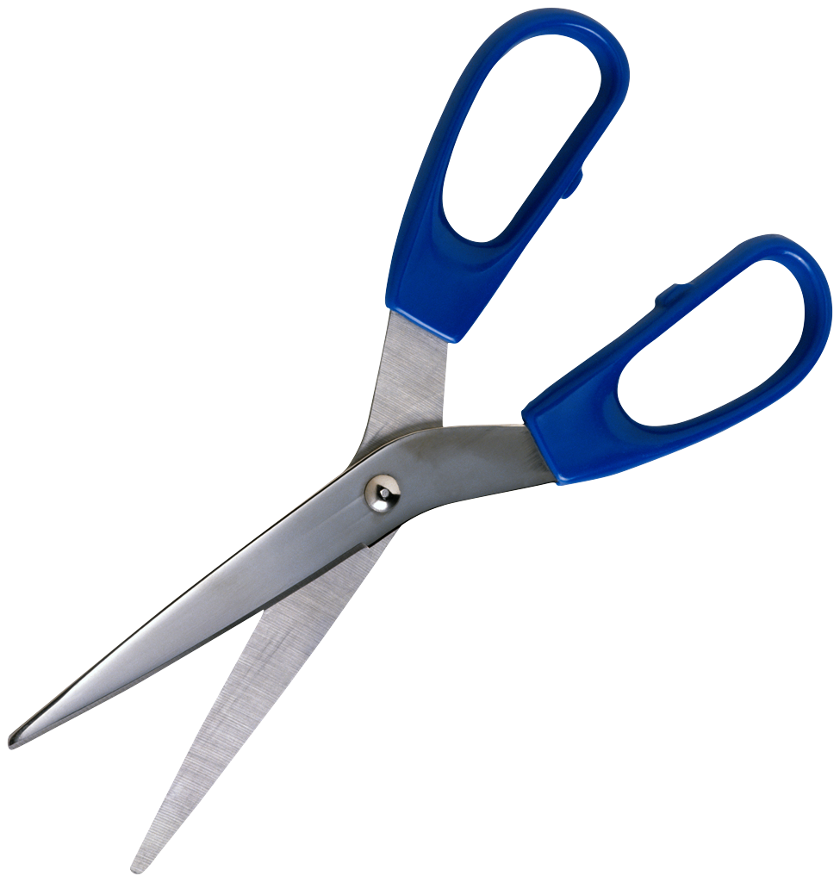
Write the vocabulary words on the front of the left side. On the inside left flaps, students should write the sentence from the book. On the inside right side, students should write an original sentence that conveys the meaning of the word. Have students underline the vocabulary word in their sentence.

